Arxiv Plots for the Golden Strategy for the ToO workshop Final Plots

The Strategy was used to produce plots for the Bright and Faint Kilonova Golden Strategy cases. It was split in three different cases depending on the Time Window (Twin) for the Day 0 observations. The cases and assumptions are discussed below

Case -1: The report suggests to take Twin > 4.76 hours so a time window of 6 hours was taken for developing the plots. The strategy is defined in such a way that the three scans + gap between scans take the complete time of the observation window. The observation starts directly at the start of the time window at 0 hours with each scan taking 1.59 hours and a gap of 0.615 hours / 36.9 mins between scans.

Case-2: The report suggests to take 3.2 < Twin < 4.7 hours so a time window of 4 hours was taken for developing the plots. The strategy follows the same logic as case 1 and the two scans + gap between scans take the complete time of the observation. Again the observation starts directly at the start of the time window at 0 hours with each scan taking 1.59 and a gap of 0.82 hours / 49.2 mins between scans.

Case-3: The report suggests to take Twin < 3.2 hours so a time window of 3 hours was taken for developing the plots. The strategy is defined to take 2.12 hours by taking the first scan in the (gri) band to last for 1.59 hours and then 0.53 hours for a scan in the r-band, and therefore the rest of the time can be used to alter the start of the observation given the time window and the gap between the scans. The first scan was taken after 30 mins of the starting of the time window which allowed a gap between scans of 0.38 hours / 22.8 mins between the scans.

Note: In all the cases for both the Bright and Faint Kilonova models, we have assumed that the time window starts 6 hours after the transient onset.

Bright Kilonova at 350 Mpc

Notebook - Igor Andreoni’s Notebook for ToO simulations
Model - "GW170817 best fit polar, theta=26deg"

Parameters

mej_dyn: Mass of dynamical ejecta – 0.005 (in solar masses)
mej_wind: Mass of wind ejecta – 0.050 (in solar masses)
phi: Angle of the ejecta distribution in the azimuthal plane – 30 degrees
theta: Polar viewing angle of the ejecta – 25.8 degrees
dist_Mpc: Distance to the source – 350 Mpc

Detections and Non Detections

Strategy Overview: Gold Events - 3 Filter Deep Strategy (350 Mpc)
Case 1
Detections:

Filter Day Magnitude
g 0.291667 20.71
g 0.425208 20.77
g 0.517083 20.78
r 0.312500 21.19
r 0.446042 21.04
r 0.537917 20.93
r 1.312500 22.11
r 2.312500 23.26
r 3.312500 24.13
i 0.333333 21.48
i 0.466875 21.31
i 0.558750 21.05
i 1.333333 21.83
i 2.333333 22.72
i 3.333333 23.05
Non-Detections: No non-detections.

Case 2
Detections:

Filter Day Magnitude
g 0.291667 20.71
g 0.392083 20.75
r 0.312500 21.19
r 0.412917 21.19
r 1.312500 22.11
r 2.312500 23.26
r 3.312500 24.13
i 0.333333 21.48
i 0.433750 21.36
i 1.333333 21.83
i 2.333333 22.72
i 3.333333 23.05
Non-Detections: No non-detections.

Case 3
Detections:

Filter Day Magnitude
g 0.312500 20.58
r 0.333333 21.15
r 0.415417 21.19
r 1.312500 22.11
r 2.312500 23.26
r 3.312500 24.13
i 0.354167 21.59
i 1.333333 21.83
i 2.333333 22.72
i 3.333333 23.05
Non-Detections: No non-detections.

Plots

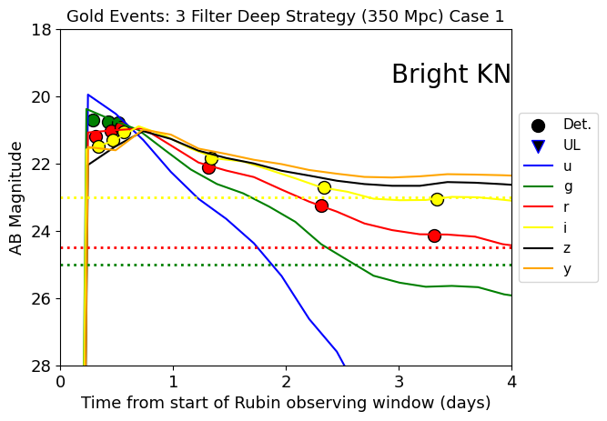
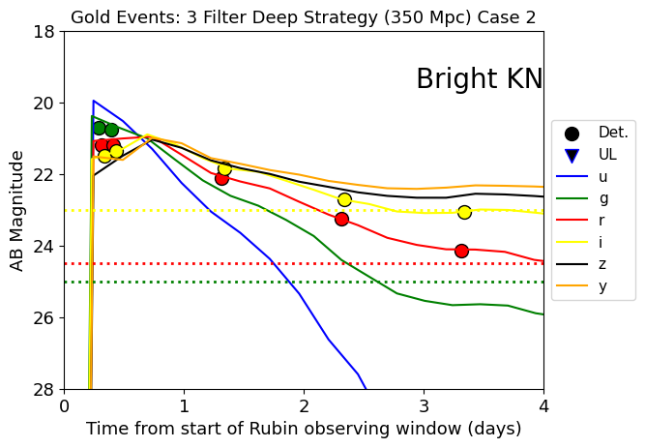
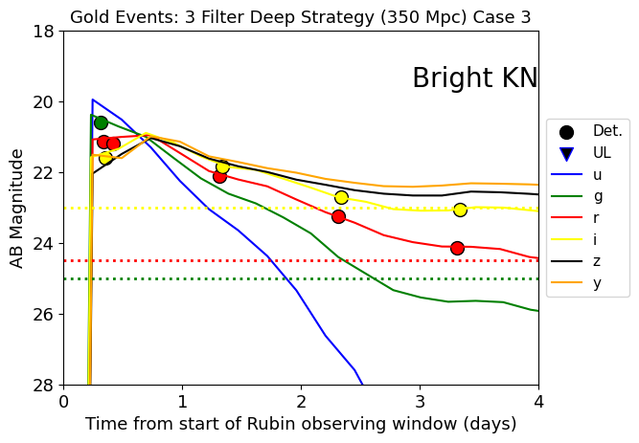

Bright Kilonova at 700 Mpc

Notebook - Igor Andreoni’s Notebook for ToO simulations

Model - "GW170817 best fit polar, theta=26deg"

Parameters

mej_dyn: Mass of dynamical ejecta – 0.005 (in solar masses)
mej_wind: Mass of wind ejecta – 0.050 (in solar masses)
phi: Angle of the ejecta distribution in the azimuthal plane – 30 degrees
theta: Polar viewing angle of the ejecta – 25.8 degrees
dist_Mpc: Distance to the source – 700 Mpc

Detections and Non Detections

Strategy Overview: Gold Events - 3 Filter Deep Strategy (700 Mpc)
Case 1
Detections:

Filter Day Magnitude
g 0.291667 21.82
g 0.425208 22.00
g 0.517083 22.10
r 0.312500 22.41
r 0.446042 22.33
r 0.537917 22.19
r 1.312500 23.53
r 2.312500 24.84
i 0.333333 22.62
i 0.466875 22.51
i 0.558750 22.40
i 1.333333 23.30
i 2.333333 24.32
i 3.333333 24.67
Non-Detections:

Filter Day Limiting Magnitude
r 3.3125 25.49
Case 2
Detections:

Filter Day Magnitude
g 0.291667 21.82
g 0.392083 21.97
r 0.312500 22.41
r 0.412917 22.39
r 1.312500 23.53
r 2.312500 24.84
i 0.333333 22.62
i 0.433750 22.61
i 1.333333 23.30
i 2.333333 24.32
i 3.333333 24.67
Non-Detections:

Filter Day Limiting Magnitude
r 3.3125 25.49
Case 3
Detections:

Filter Day Magnitude
g 0.312500 21.77
r 0.333333 22.45
r 0.415417 22.40
r 1.312500 23.53
r 2.312500 24.84
i 0.354167 22.75
i 1.333333 23.30
i 2.333333 24.32
i 3.333333 24.67
Non-Detections:

Filter Day Limiting Magnitude
r 3.3125 25.49

Plots

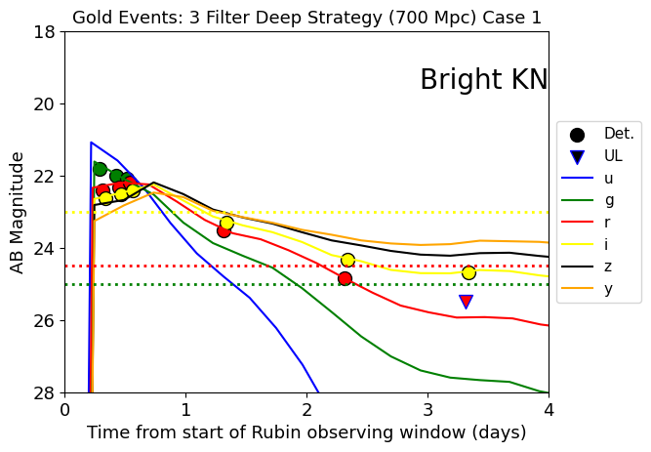
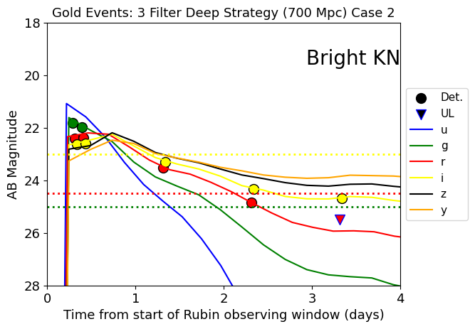
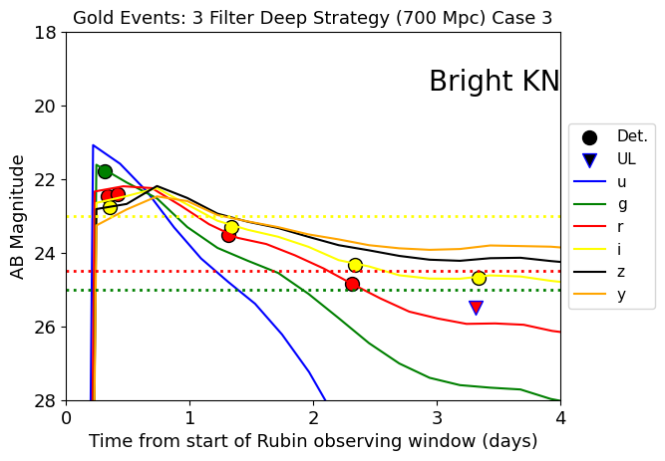

Faint Kilonova at 350 Mpc

Notebook - Developed by Meet using the redback example
Model - One Component Kilonova Model

Parameters

mej: Ejecta mass – 0.05 (in solar masses)
t0_mjd_transient: Start time of the transient – 0 (in Modified Julian Date, MJD)
redshift: Redshift corresponding to 350 Mpc – 0.074816848
t0: Starting time of the transient, set to t0_mjd_transient – 0
temperature_floor: Minimum temperature – 3000 K (floor value to prevent extremely low temperatures in the model)
kappa: Gray opacity – 1 (represents the opacity of the ejecta material)
vej: Minimum initial velocity of the ejecta – 0.2 (in units of the speed of light, c)
ra: Right ascension of the kilonova’s location – 1.0 degrees
dec: Declination of the kilonova’s location – 1.5 degrees

Plots

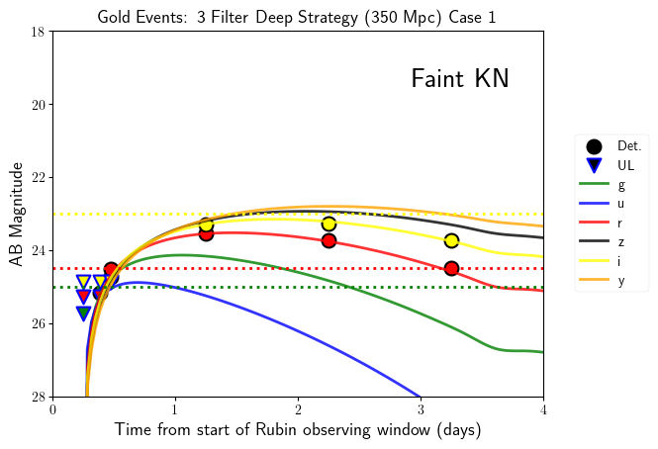

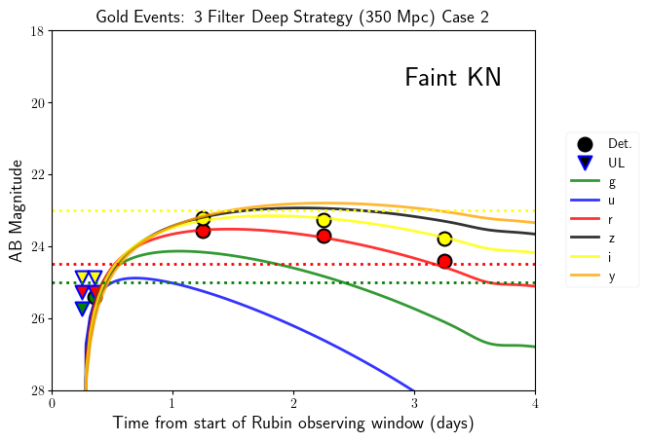

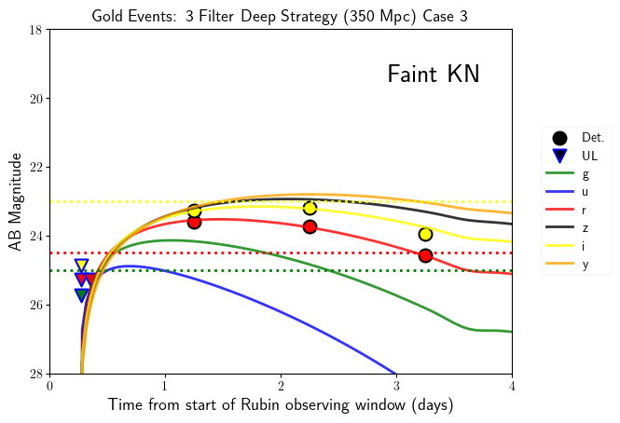

Faint Kilonova at 700 Mpc

Notebook - Developed by Meet using the redback example
Model - One Component Kilonova Model

Parameters

mej: Ejecta mass – 0.05 (in solar masses)
t0_mjd_transient: Start time of the transient – 0 (in Modified Julian Date, MJD)
redshift: Redshift corresponding to 700 Mpc – 0.14309633
t0: Starting time of the transient, set to t0_mjd_transient – 0
temperature_floor: Minimum temperature – 3000 K (floor value to prevent extremely low temperatures in the model)
kappa: Gray opacity – 1 (represents the opacity of the ejecta material)
vej: Minimum initial velocity of the ejecta – 0.2 (in units of the speed of light, c)
ra: Right ascension of the kilonova’s location – 1.0 degrees
dec: Declination of the kilonova’s location – 1.5 degrees

Plots

